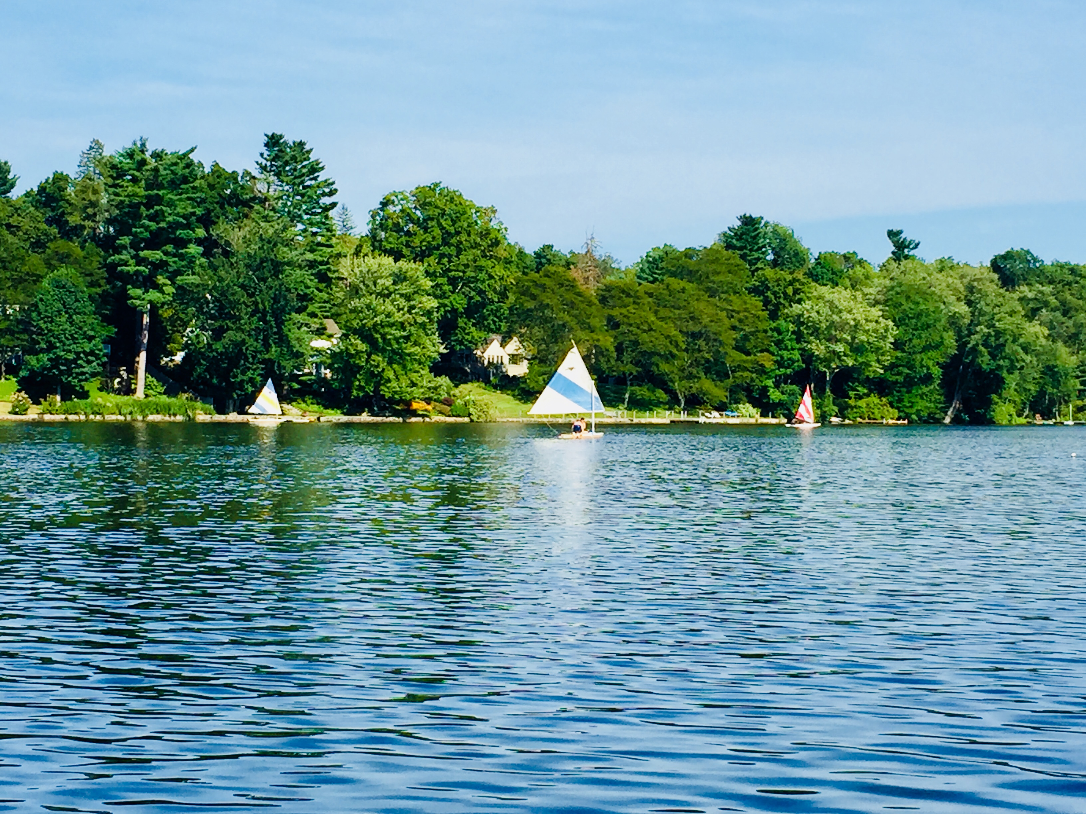
Hydro-dredging Investigation Update
Truesdale Lake Planning Group

This document is a conversion of the presentation originally given June 18, 2018 at the Open Truesdale Lake Meeting at the South Salem Presbyterian Church.

The presentation can be found here:
http://truesdalelake.com/2018/06/slides-from-june-19-open-lake-meeting/

Truesdale Lake Planning Group Update

The goal for the working group is to identify strategies (investments) beyond the in-season treatment that improve the 'health of the lake' where health is defined as...
  - Real health - chemistry & biology (science)
  - Perceived health - property values, lake use (analysis, opinion)
Committee Members
  - Lara Gorton, TLPOA, Lake Management Chair
  - David Sachs, TLPOA, President
  - Sue Enos, TLPOA member
  - Dave Douglas TLPOA member
  - Cliff Munz, TLPOA member
  - Steve Macaluso, unaffiliated
  - Peter Putignano, unaffiliated
  - Laura Sanchick, TEA member

Hydro-dredging

Our journey thus far (a summary of our progress)
  - Grass roots support to investigate hydro-dredging
  - Community-wide initiative
  - Investigation timeline
  - Results of our consultant study
  - DEC meeting and response
  - Lessons Learned and Next Steps

Hydro-dredging Consultations

Input and recommendations from
  - Land Tech Study
  - SUNY Lake Management Study – Christian Jenne
  - Princeton Hydro – Michael Martin
  - Environmental Land Solutions – Kate Throckmorton
  - Tighe & Bond – Brandee Nelson
  - Pond & Lake Connection – James Gorman
  - NY Department of Environmental Conservation (DEC) – Josh Fisher and Sarah Pawliczak
  - Lewisboro town contacts*
    - Wetlands Inspector – Jan Johannessen
    - Highway Superintendent – Peter Ripperger
    - Town Supervisor – Peter Parsons

Hydro-dredging Investigation Timeline

June 2017
  - Hydro-dredging presented after TLPOA annual meeting
  - Ad-hoc planning committee formed
July 2017
  - Met with Lewisboro Wetlands Inspector Jan Johannson
  - Researched consultants to provide scope and recommendations for dredging
August 2017
  - Hydro-dredging FAQs posted
September 2017
  - Special meeting with the community to introduce consultant Kate Throckmorton from Environmental Land Solutions (ELS) and review consultant proposal
  - Raised money from the community to fund Task 1 of ELS’s proposal for Pre-Design and Feasibility Plans
October 2017
  - Weekly meetings/conference calls with ELS on scope, timeline, permitting and logistics
November 2017
  - ELS presents results of Task 1

ELS Preliminary Plan P1 (figure 1)

- Identified symptomatic problems
- Best management practices
- Active management practices
- Goals
- Recommendations

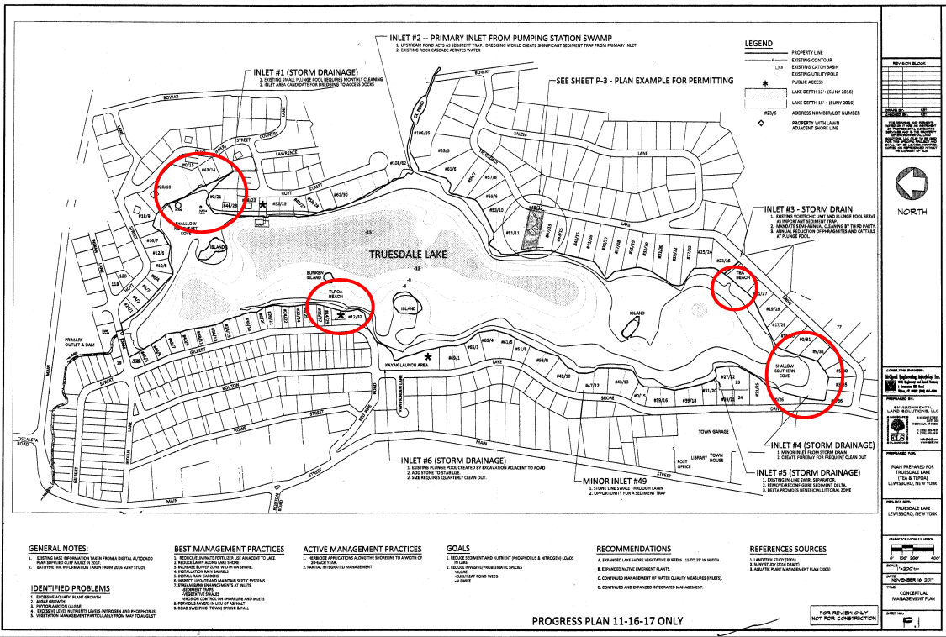

ELS Preliminary Plan P2 (figure 2)

- Management goals
- Prime areas for dredging (NE cove, TEA Beach, South Cove, TLPOA Beach)
- Potential areas for dredging deposits
- Site plan information for dredging
- Goals

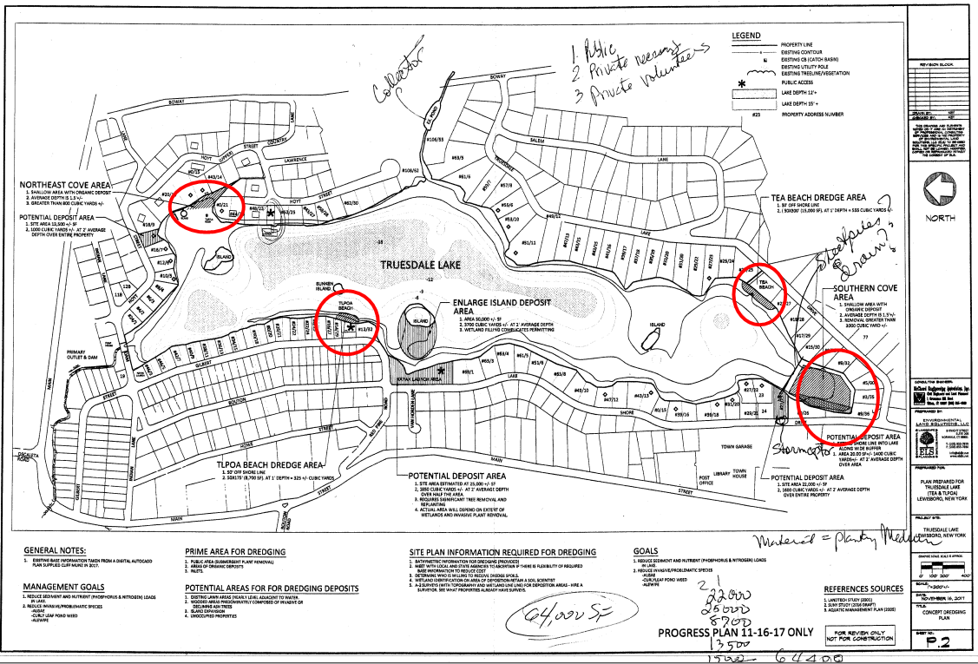

ELS Conclusions (Table 1)

Dredge locations | Area within lake (sf.) | Dredge spoils (yards) assuming 2’ average removal depth | Known public spaces (boat launches only)  for dredge spoils deposits area  (assuming 2’ depth max.) | Private properties  willing to accept spoils | Short fall of placement  (yards)
1 Public access areas  (TEA & TLPOA beach areas) | 16,000± sf | 1,200 ±yards | 25,000± sf  (1850± yards) | (TBD) | areas may accommodate  spoils if entire areas are used
2 Public access and major inlets | 16,000+30,000=  46,000± sf | 3,400± yards | 25,000± sf  (1850± yards) | (TBD) | 2215± yards
3 Public areas, inlets and southern cove | 46,000+99,200=  145,200± sf | 10,750± yards | 25,000± sf  (1850± yards) | (TBD) | 8,900± yards
4 Dredging to deepen areas over 10' by 3' | 561,675± sf | 62,500± yards | 25,000± sf  (1850± yards) | (TBD) | floating dredge may not have depth to reach, and permitting is problematic 60,650± yards

Recommended Alternatives

- Assessing alternatives objectively (impact on health, permit-ability, cost thru permitting, cost thru execution, ...)
  - Hydro-dredging
  - Draining (siphoning / pumping)
  - Draining (restore the valve)
  - Draining + dry dredging
  - Catch pond / basin maintenance with / without above
  - Do nothing beyond in-season treatments

Hydro-dredging Investigation Timeline

December 2017
  - Discussed recommended alternative to lower the lake level over the winter
  - Received proposal to evaluate dam and spillway from Tighe & Bond
  - Members of the committee met with Lewisboro town officials
February 2018
  - Contacted the DEC to schedule initial conversations
March 2018
  - Prepared DEC Pre-Application materials to schedule DEC meeting
April 2018
  - Submitted DEC Pre-Application
  - Conducted site visit with the DEC at Truesdale Lake
May 2018
  - Received DEC response with further permitting requirements

Truesdale Lake Dam Cross Section (Figure 3)

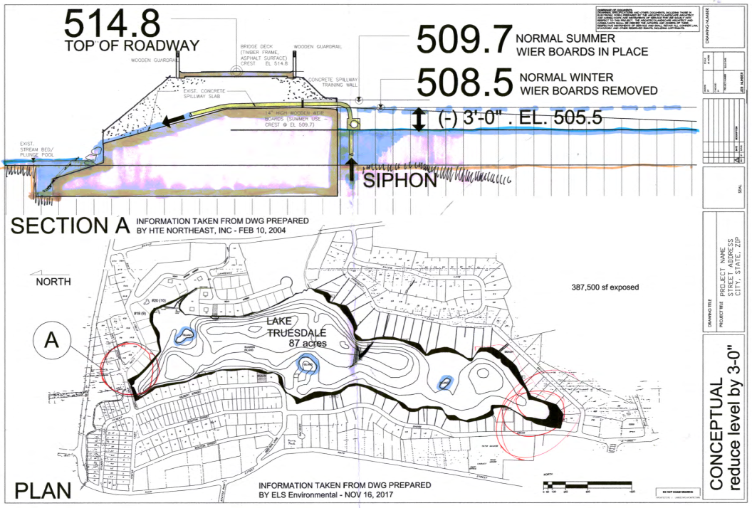

DEC Application Project Description & Purpose

The Truesdale Lake Property Owners Association (TLPOA) would like to request a conceptual review of proposed methods to mitigate the accumulated organic silt deposits at various areas around the lake via a combined method of hydro-dredging and water level management.

The organic material would be collected and pumped to designated areas for dewatering utilizing bio-bags as well as a natural dewatering/compaction process from controlled lowering of the water level. The dewatered organic material would ultimately be raked out as a new shoreline base planting medium.

DEC Response – Dredging

Protection of Waters – Excavation/Fill in Navigable Waters & Section 401 Water Quality Certification

Truesdale Lake, class B, is a regulated waterbody and an Excavation/Fill in Navigable Waters permit is required for any excavation or fill below Mean High Water (MHW).

The original project involved dredging approximately 64,000 cubic yards of material at 4 locations, however, that may change based on our discussion yesterday at the site visit.

Protection of Waters permit issuance standards require that a project:
- Be reasonable and necessary;
- Will not endanger the health, safety or welfare of the people of the State of New York; and
- Will not cause unreasonable, uncontrolled or unnecessary damage to the natural resources of the State.

DEC Response – Drawdown Lake Level

You are also proposing to drawdown Truesdale Lake by approximately 3 feet below the existing water level.
- The drawdown will be conducted by the use of a siphon in the existing dam.
- The purpose of the drawdown is to attempt to control aquatic vegetative growth and to allow sediments to compact.
- No permits are required from the DEC to conduct this activity. However, to ensure the protection of aquatic organisms within Truesdale Lake, and Truesdale Stream, the following precautions should be taken:
    - An adequate water surface area and depth for aquatic organisms to concentrate and survive through the winter must be maintained;
    - Adequate flow to the stream below the dam, Truesdale Stream, Water Index Number H-31-P 44-35-P 109-6-13, class C, should be maintained even during the lake refilling period;
    - Complete drawdown by October 15; and
    - Complete refill by May 1.
Please also be aware that if any repairs are proposed to the dam, or if any work is proposed by residents of the lake, the DEC should be consulted for potential permits.

DEC Response – Other Considerations

Army Corps of Engineers
An Army Corps of Engineers permit may be required pursuant to Section 404 of the Clean Water Act. If a Section 404 permit is required, you will also require a Water Quality Certification pursuant to Section 401 of the Clean Water Act. Issuance of these certifications in NYS has been delegated to the DEC. Please contact the Army Corps of Engineers in New York City, at 917-790-8511, as soon as possible, for any permitting they might require.

Uniform Procedures
Under Uniform Procedures, 6 NYCRR §621, each permit type has designations for minor actions, all other actions are major.
- Excavation/Fill – minor actions include total area of excavation or placement of fill of 5,000 square feet or less; in-kind and in-place repair and rehabilitation would be considered minor regardless of the area of disturbance; maintenance dredging occurring at least once every 10 years; and fill of less than 100 cubic yards; and
- Water Quality Certification – minor actions include projects that will not exceed the minor project thresholds established for protection of waters.
A determination will be made once a formal application has been submitted. Major actions require a minimum 15-day public comment period once the application is deemed complete.

State Environmental Quality Review (SEQR)
A short Environmental Assessment Form must be submitted with the application package. No application can be deemed complete until the Lead Agency or DEC determines the significance of this action in writing.

NYC Department of Environmental Protection (NYCDEP) Watershed
Please note that this project is located within the NYCDEP East-of-Hudson watershed. Contact NYCDEP directly about any jurisdiction which they may have.
State Pollution Discharge Elimination System (SPDES) Stormwater – Construction
Coverage under the SPDES General Permit for Stormwater Discharges from Construction Activity (GP-0-15-002), is required for construction projects that disturb 5,000 square feet or more of land within the NYCDEP East-of-Hudson Watershed. As this site is within a Municipal Separate Storm Sewer System (MS4) community, the Stormwater Pollution Prevention Plan (SWPPP) must be reviewed and accepted by the municipality, and the MS4 Acceptance Form submitted with the SWPPP and the application for coverage, in accordance with the application instructions.

Solid Waste
Material that will be removed from the lake will need to be characterized to determine whether it is clean fill, qualifies for a Beneficial Use Determination (BUD), or will need to be handled as solid or hazardous waste. Please contact Lee Reiff, NYSDEC Division of Materials Management at 845-256-3134, as soon as possible, for guidance on testing of the material. Information on BUDs, including pre-determined BUDs, is available on the DEC website at http://www.dec.ny.gov/chemical/8821.html.

What we learned & next steps

Conclusions
  - Dredging (excavation/removing any material from the lake)
    - Short term and expensive solution
    - Significant permitting process and potential unknowns
    - Regular dredging required to maintain improvements
  - Lowering the lake level
    - Widely recommended by all experts consulted
    - Historically part of the regular lake management plan at Truesdale Lake
    - Relatively inexpensive solution
    - Compresses silt and helps mitigate weed growth
    - No negative effect to lake usage or wildlife habitat
Next steps
  - Get proposal for solution to lower the lake level (Pond & Lake Connection)
  - Determine community interest to continue and move forward on dredging
  - Discuss future plans for long-term lake health improvement activities

